**DAILY ONLINE ACTIVITIES SUMMARY**

|  |  |  |  |  |  |  |  |  |
| --- | --- | --- | --- | --- | --- | --- | --- | --- |
| **Date:** | **01/06/2020** | | | | | **Name:** | **Archana J C** | |
| **Sem & Sec** | **4th**  **‘A’** | | | | | **USN:** | **4AL18CS011** | |
| **Online Test Summary** | | | | | | | | |
| **Subject** | | **Complex analysis, probability and statistical methods** | | | | | | |
| **Max. Marks** | | **19** | | **Score** | | | **30** | |
| **Certification Course Summary** | | | | | | | | |
| **Course** | **Python and Django full stack web developer bootcamp** | | | | | | | |
| **Certificate Provider** | | | **Udemy** | | **Duration** | | | **2hours** |
| **Coding Challenges** | | | | | | | | |
|  | | | | | | | | |
| **Status: Completed** | | | | | | | | |
| **Uploaded the report in Github** | | | | | **Yes** | | | |
| **If yes Repository name** | | | | | **archana_j_c** | | | |
| **Uploaded the report in slack** | | | | | **Yes** | | | |

Online Test Details: (Attach the snapshot and briefly write the report for the same)

1. **Complex analysis, probability and statistical methods:** The online test was from module 5 which was about probability distribution. There were 20 questions where 10 was for 1 mark each and the remaining 10 for 2 marks each and the duration was 45 minutes. The questions were optimal and were easy. The score that I got in the test is 19/30.

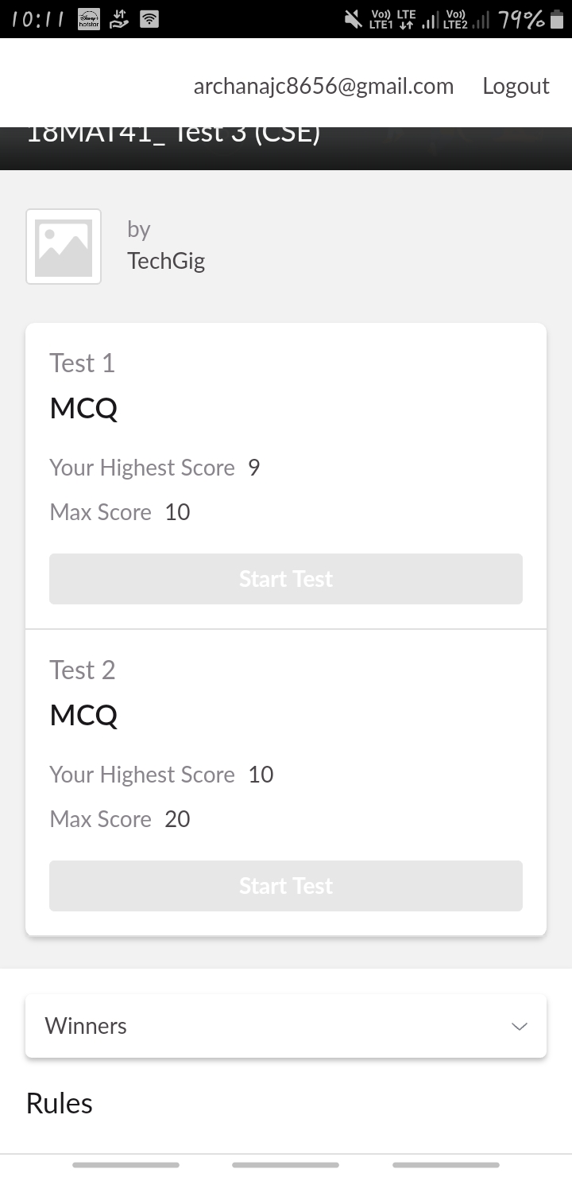

Certification Course Details: (Attach the snapshot and briefly write the report for the same)

COURSE NAME : **Python and Django full stack web developer bootcamp**

CERTIFICATION PROVIDERS : Udemy

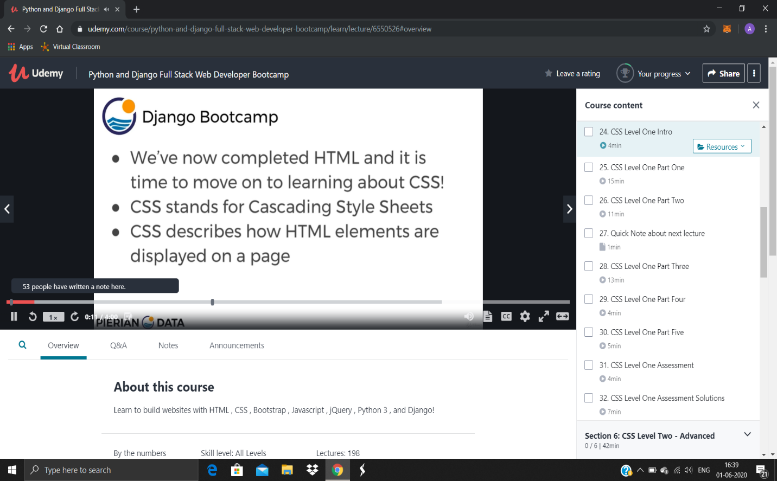

Coding Challenges Details: (Attach the snapshot and briefly write the report for the same)

Today I’m done with some java programs. The solution are already uploaded in github repository.

